**ADVANCED Excel SPREADSHEET 5**

**1. How many types of conditions are available in conditional formatting on Excel?**

**ANS-1. Conditional formatting presets**

They are grouped into three categories: Data Bars are horizontal bars added to each cell, much like a bar graph. Color Scales change the color of each cell based on its value. Each color scale uses a two- or three-color gradient.

**2.**  **How to insert border in Excel with Format Cells dialog?**

1. **ANS-2.** Select one or more cells to which you'd like to add borders.
2. Open the Format Cells dialog box by doing one of the following: ...
3. In the Format Cells dialog box, switch to the Border tab and choose the line style and color first. ...
4. When done, click OK.

**3.**  **How to Format Numbers as Currency in Excel?**

1. **ANS-3.** Select the cells that you want to format and then, in the Number group on the Home tab, click the down arrow in the Number Format box.
2. Choose either Currency or Accounting.

**4. What are the steps to format numbers in Excel with the Percent style?**

**ANS-4.** On the Home tab, in the Number group, click the icon next to Number to display the Format Cells dialog box. In the Format Cells dialog box, in the Category list, click Percentage. In the Decimal places box, enter the number of decimal places that you want to display.

**5. What is a shortcut to merge two or more cells in excel?**

**ANS-5.** ALT +H+M+M

**6. How do you use text commands in Excel?**

## ANS-6. 1.Left()

You can use the Left function when you want to extract the leftmost characters from a string. Syntax =left(text, num_char)

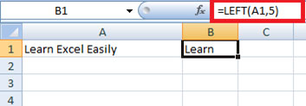

Similarly, you can also use the Right function to extract the rightmost characters from a string.

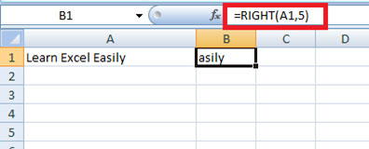

2.  Len ()

Len function in Excel helps you to know the length of a string that is number of characters in a string. Syntax = LEN(text)

Note – Spaces are included while calculating length.

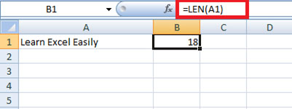

3.  Mid ()

Mid function in Excel is used to extract the characters from the middle of a string. Syntax = MID(text, start_char, num_chars)

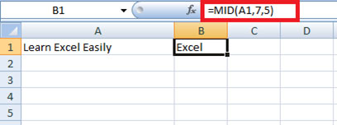

4.  Find ()

Find function in Excel is used when you want to know the position of certain characters in a particular string. Syntax =FIND(find_text, within_text,[start_num])

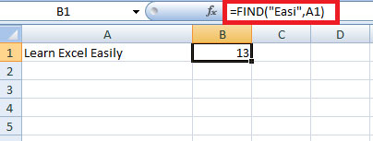

5.  Proper ()

Proper function in Excel capitalizes each word in the string that is, it converts the case into proper case. Syntax =PROPER(Text)

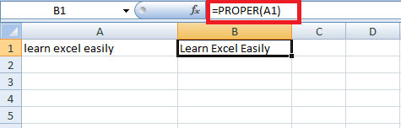

6.  Rept ()

Rept function in Excel is used when you want a certain text to be repeated certain number of times. Syntax =REPT(Text, number_times)

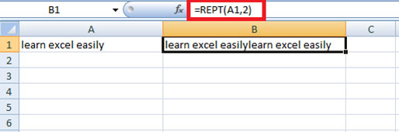

7. Trim()

Trim function in Excel removes the unnecessary spaces from a particular string.  
Syntax =TRIM(Text )

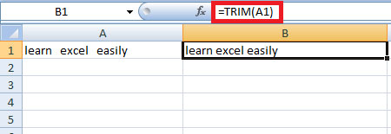

8.  Upper()

Upper function in Excel converts the text into Upper case from lower case. Syntax =UPPER(Text )

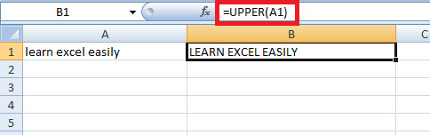

9.  Substitute ()

Substitute function in Excel helps to replace existing text with a new text in a particular string. Syntax =SUBSTITUTE(text, old_text, new_text, instance number)

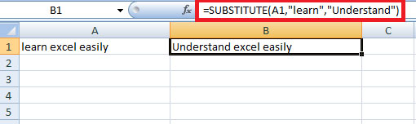

10.  Concatenate ()

Concatenate function in Excel helps to join the text of two or more cells. Syntax =CONCATENATE(text1, text2….)

